**More Forms**

Using the previous assignment "Hook Form", add error messages.

1. If the First Name or Last Name is less than 2 characters, output an error message saying that field must be at least 2 characters.
2. The e-mail is less than 5 characters, say the field must be at least 5 characters.
3. The passwords must match and be at least 8 characters.

These messages can appear right when you render the page, and will disappear in real time.

Hint: Use state and conditional rendering.

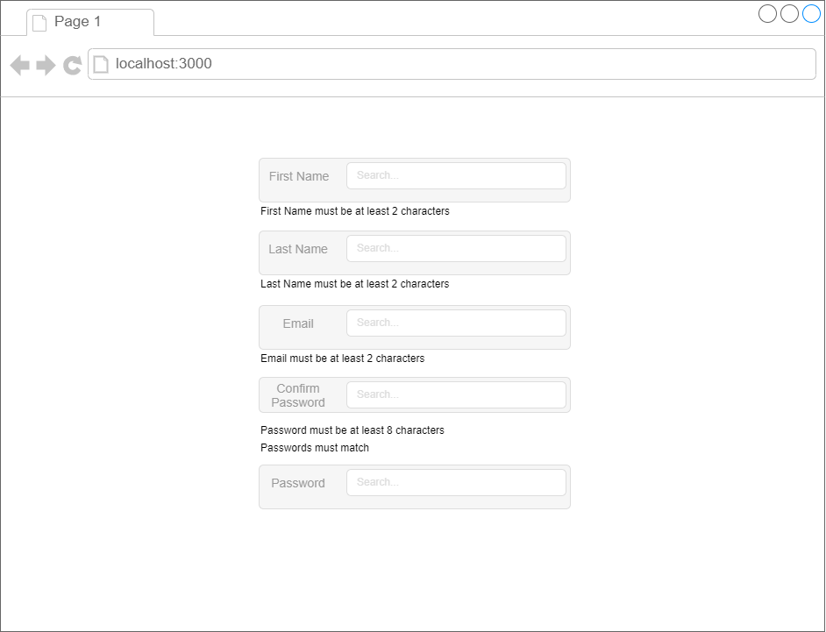

* Top of Form
  + Create validations for First Name
  + Create validations for Last Name
  + Create validations for Email
  + Create validations for password and confirm password
  + Sensei Bonus: Only show the validations if the input is not blank (You should not see the error messages if you have not typed anything in)

Bottom of Form